may 16, 2022

The Alu-Topline desktop enclosure series has a new variant
A little bit more of everything: bigger touch display, more installation space and increased IP protection

Following requests by many customers, BOPLA is adding a further version to its popular Alu-Topline enclosure system. The new desktop enclosure is optimised for the integration of typical 10.1” touch displays and provides considerably more space than the enclosures which were previously available in this series. In addition, thanks to a change to the design of the seal, the standard version of the new Alu-Topline ATPH-IP 2385 now offers IP65 protection. Visible design seals provide colour accents as an option. The new variant will be available starting in June.

The body of BOPLA’s Alu-Topline enclosure consists of natural-coloured aluminium extruded profiles and, when shortened to the appropriate length, can be adapted for the relevant application. Here the enclosure dimensions match the typical touch screen / display sizes of 7.0” and 10.1”. ABS plastic covers in the two standard colours of graphite grey (similar to RAL 7024) and black (similar to RAL 9005) are available as a profile end. Special colours are available on request.

The split enclosure profile allows easy access to the interior and also fast, simple mounting of the electronic components. The lower half of the new ATPH-IP 2385 enclosure has various inserts on the underside for swivellable slot nuts – for example for wall mounting – and screw channels which can be used as an alternative for mounting PCBs.

In addition to various wall mountings, accessories for the Alu-Topline enclosure system include insulating strips for PCB mounting on the profile, and also rubber feet.

The original ATPH 18xx variants of the Alu-Topline enclosures provide IP40 protection as standard. Combining the factory-fitted round cord seal with a TPE seal gives IP54 protection.

(1,846 characters with spaces)

About BOPLA
For more than 50 years, we at Bopla Gehäuse Systeme GmbH, whose headquarters are in the East-Westphalian town of Bünde, have been developing and manufacturing application-oriented electronic enclosures made of plastic and aluminium, and also HMIs on the basis of touch screens and membrane keypads. Our targeted enclosure products are found among others in measurement, control and instrumentation applications, in machinery and plant engineering, and in medical and railway technology.
We carry out not only the manufacturing of the enclosure for our customers, but also mechanical processing, printing and equipping. On request we also carry out the complete assembly of the application including inspection and function tests, and take on the integration of membrane keypads and touch displays.
In addition to individual enclosure solutions for our customers, we are also well-known for our exceptionally wide range of standard products which are available ex-warehouse. All this means that we are one of the leading brands in the enclosure technology sector, always ready to support and advise our customers worldwide with their development projects.
In addition, we have been marketing Kundisch GmbH’s new and innovative HMI technologies in our high-end enclosure system solutions since 2021.
We have approximately 500 employees worldwide in various production and marketing companies. Two hundred of our employees work at our Bünde headquarters. We are a subsidiary of the Swiss company of Phoenix Mecano AG, which ensures that our products and services are available all over the world.
More information is available on www.bopla.de.

(1,638 characters with spaces)

Image overview

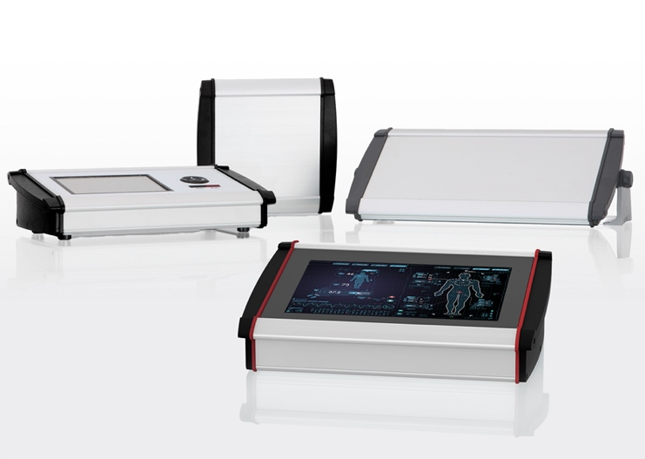
AluTopline_Gruppe.jpg: BOPLA is adding a new model (front) to its Alu-Topline enclosure system. In addition to more installation space and IP65 protection as standard, the ATPH 2365-IP offers the opportunity to integrate a large 10.1” touch display – Image source: Bopla Gehäuse Systeme GmbH

Meta Title
New desktop enclosure from BOPLA

Meta Tag
BOPLA is adding to its Alu-Topline enclosure system with a new model which includes a 10.1“ touch display, more installation space and IP65

Keywords
Electronics enclosures touch display, desktop enclosures aluminium, desktop enclosures touch display, aluminium enclosures wall mounting, BOPLA

Deep links
https://www.bopla.de
https://www.bopla.de/gehaeusetechnik/product/alu-topline.html

Press office
Köhler + Partner GmbH
Brauerstr. 42 • 21244 Buchholz i.d.N.
Telephone +49 4181 928928-0 • Fax +49 4181 928928-55
info@koehler-partner.de • www.koehler-partner.de

