31.03.2022

Illuminated membrane keypads
The most up-to-date LED technology ensures maximum operating safety

As a system supplier, enclosure specialist BOPLA also has special levels of expertise in developing and mounting man-machine interfaces. BOPLA, based in Bünde, offers a wide range of ultra-modern technologies which ensure maximum operating safety, even in poor light conditions and dark work environments.

By integrating light guides and scattering elements, BOPLA offers optimal lighting results for night design and daylight. The portfolio of illuminated membrane keypads consists of various designs and technologies which guarantee homogeneous, efficient and energy-saving illumination. In bad light conditions, the illuminated membrane keypads make work much easier, and in this way they ensure a reduction in errors by minimising incorrect operations. Even in dark rooms, this guarantees 100% secure operability. In doing this, the number of keys and their positions, the shape of the keys and the graphic design can be adapted individually to the relevant requirements.

Backlit Profiline for the highest standards
Whether vehicle technology, payment systems or medical technology – thanks to its long operating life, low energy consumption and optimal ease of use, the backlit Profiline membrane keypad is at home in many sectors. The space-saving technology used here incorporates dual-function key inlays which also act as a light guide. A special RGB LED allows a key to light up in various colours – a very wide range of mixed colours in addition to red, green and blue. In this way, different displays are possible inside a single key.

Even light distribution
In addition, with its NLF backlight (Night-Light-Foil) and EL foils (electro-luminescence foils) BOPLA offers two more technologies for even light distribution.. With the use of LEDs, NLF technology makes it possible to realise almost all back-lighting requirements in robust, compact and effective ways, from the single key to a large area. A low mechanical height and mechanical flexibility are additional advantages. EL foils also emit homogeneous light over the entire surface. Normally EL membranes are less than 0.3 mm thick, so they are extremely space-saving.

The ideal solution for every application
Whether for a narrow control panel with few keys or a complex operating surface with additional elements, BOPLA’s extensive portfolio, comprehensive expertise and depth of application skills create a background lighting solution for every situation. By the way, in addition to improved operability in poor lighting conditions, the illuminated membrane keypad also offers an option for feedback for certain switch positions.

(2,598 characters with spaces)

About BOPLA
For more than 50 years, we at Bopla Gehäuse Systeme GmbH, whose headquarters are in the East-Westphalian town of Bünde, have been developing and manufacturing application-oriented electronic enclosures made of plastic and aluminium, and also HMIs on the basis of touch screens and membrane keypads. Our targeted enclosure products are found among others in measurement, control and instrumentation applications, in machinery and plant engineering, and in medical and railway technology.
We carry out not only the manufacturing of the enclosure for our customers, but also mechanical processing, printing and equipping. On request we also carry out the complete assembly of the application including inspection and function tests, and take on the integration of membrane keypads and touch displays.
In addition to individual enclosure solutions for our customers, we are also well-known for our exceptionally wide range of standard products which are available ex-warehouse. All this means that we are one of the leading brands in the enclosure technology sector, always ready to support and advise our customers worldwide with their development projects.
In addition, we have been marketing Kundisch GmbH’s new and innovative HMI technologies in our high-end enclosure system solutions since 2021.
We have approximately 500 employees worldwide in various production and marketing companies. Two hundred of our employees work at our Bünde headquarters. We are a subsidiary of the Swiss company of Phoenix Mecano AG, which ensures that our products and services are available all over the world.
More information is available on www.bopla.de.

(1,638 characters with spaces)

Image overview
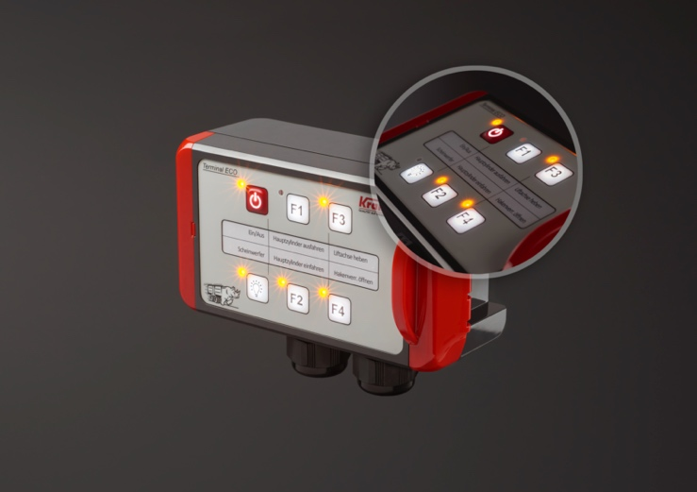
BOPLA-Beleuchtete-Folientastatur.jpg: Illuminated membrane keypads from BOPLA: The most up-to-date LED technology ensures safe, secure operation.
Image: BOPLA

Meta Title
BOPLA: Illuminated membrane keypads

Meta Tag
Enclosure specialist BOPLA creates the optional backlighting solution for every application. Learn more!

Keywords
Illuminated membrane keypad, illumination, lighting, enclosures, BOPLA

Deeplinks
https://www.bopla.de/eingabeeinheiten/folientastaturen/beleuchtete-folientastaturen.html
https://www.bopla.de/eingabeeinheiten/folientastaturen/beleuchtete-folientastaturen/profiline-hinterleuchtet.html
https://www.bopla.de/eingabeeinheiten/folientastaturen/beleuchtete-folientastaturen/nlf-backlight.html
https://www.bopla.de/eingabeeinheiten/folientastaturen/beleuchtete-folientastaturen/el-folien.html

Press office
Köhler + Partner GmbH
Brauerstr. 42 • 21244 Buchholz i.d.N.
Telephone +49 4181 928928-0 • Fax +49 4181 928928-55
info@koehler-partner.de • www.koehler-partner.de

